**Activity**

**Ex. 1**

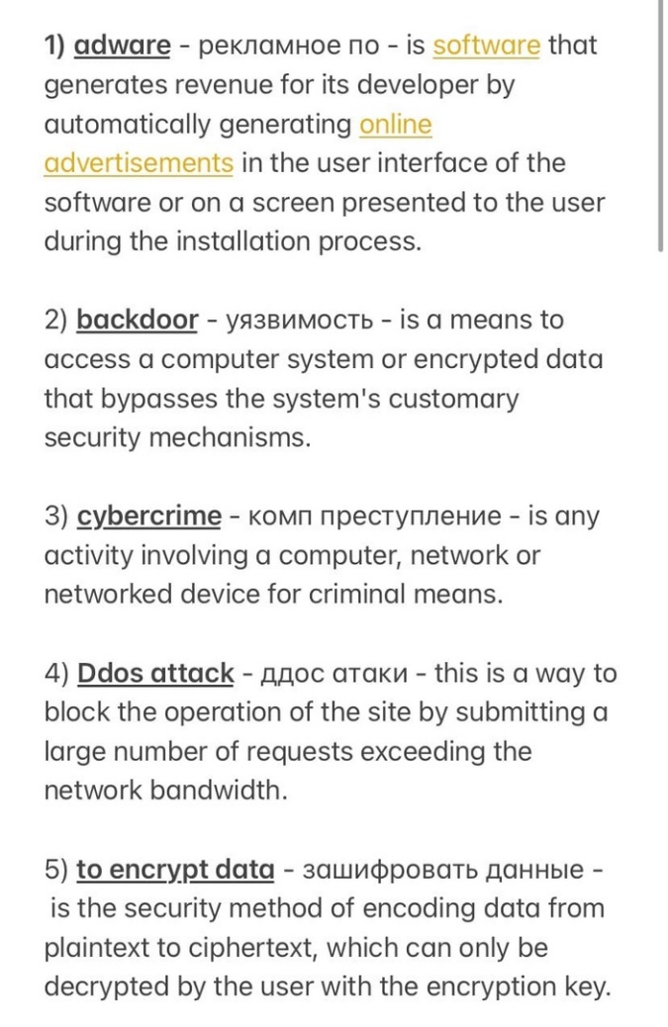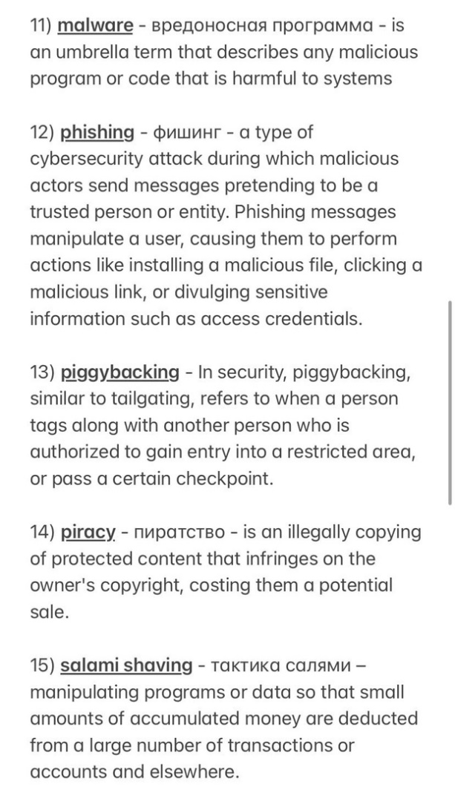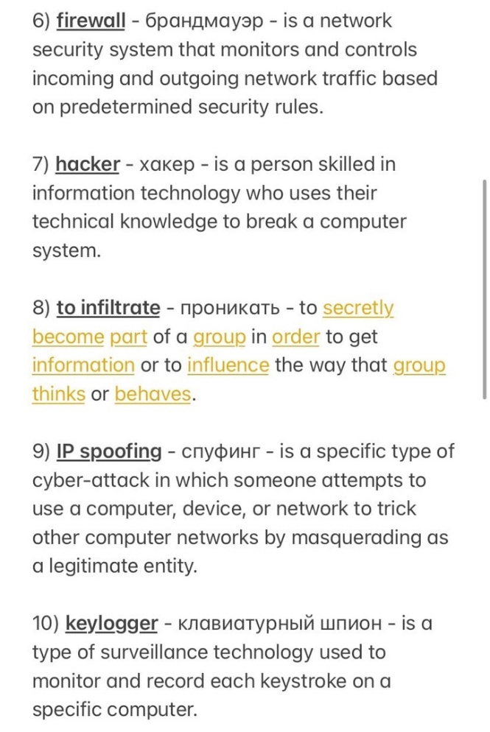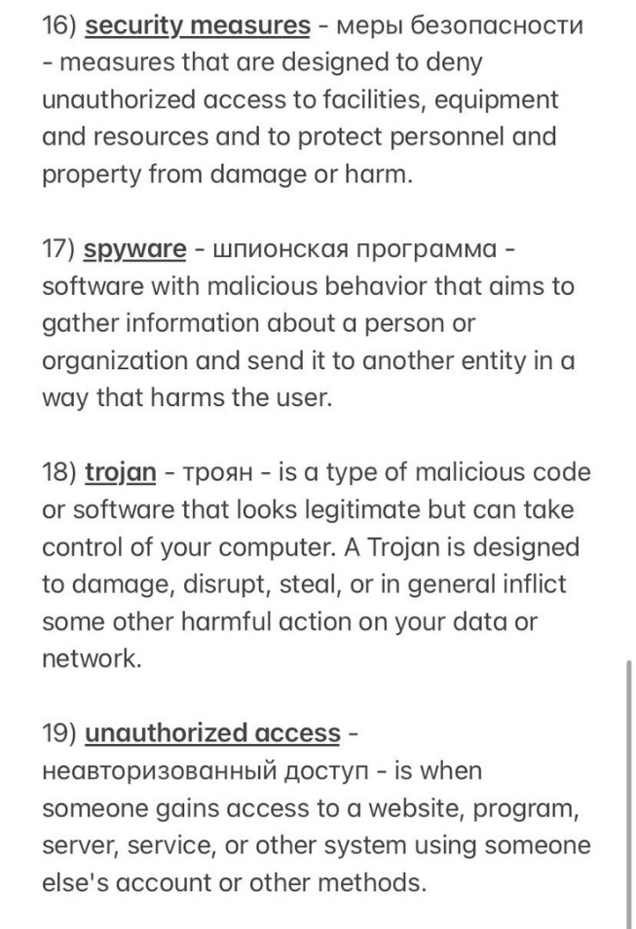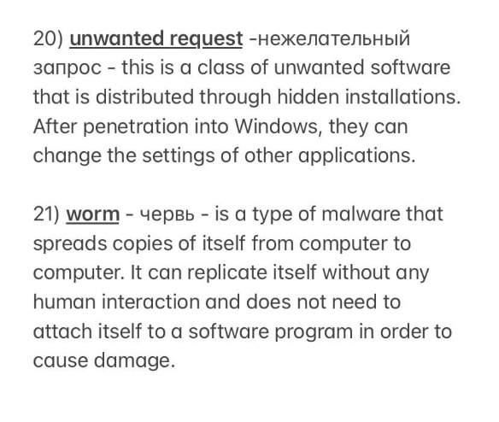

**Ex. 2**

1 - A  
2 – C

**Ex. 3**

1 d  
2 b  
3 f  
4 c  
5 e  
6 a

**Ex. 4**

1) until  
2) of  
3) like  
4) in  
5) to  
6) by  
7) into  
8) without  
9) from  
10) with

**Ex. 5**

1) Trojan horse  
2) Spyware  
3) Adware  
4) replicate  
5) Piggybacking (наверное)

**Ex. 6**  
1) triggered  
2) standalone (автономный вау)  
3) intervention  
4) dormant (бездействующий вау х2)  
5) malicious code  
6) host file  
7) infect

**Ex. 7**  
a) Through infected files, websites or mail.  
b) User himself by activating infected file.  
c) Ransomware locks your computer or access to the data at the computer and demands money.  
d) Worms replicate themselves and often spread via email by sending letter with a copy of themselves.  
e) viruses need a host file and activation by user while worms are standalone and can start to execute without direct activation.

1) ...via questionable file downloads, visiting infected websites...  
2) ...often originated on the Internet and spread when...  
3) ...is a harmful piece of software that looks legitimate.  
4) ...PC hostage and demands money... / ... computer threatening to destroy...  
5) Spyware secretly gathers private...  
6) ...can replicate themselves and... / ...on a network causing major damage.

**Ex. 8**  
1) spyware  
2) virus?? я хз  
3) adware  
4) keylogger  
5) worms  
6) trojan horse  
7) ransomware

**Ex. 9**  
1C 2B? 3A

**Prof Eng in use.**  
**Ex. 26.1.**  
1 - a  
2 - f  
3 - d  
4 - b  
5 - e  
6 - c

**Ex. 26.2.**  
1) malware  
2) digital certificate  
3) firewall  
4) spyware  
5) virus  
6) antivirus  
7) scanner